Product Help

Location Master
- _{Location Master}
Location Master contains different section/rack of drug storage. User can add/edit/delete Location Master Like Rack1/Section1 & its sub location like Box1, Box2 etc.

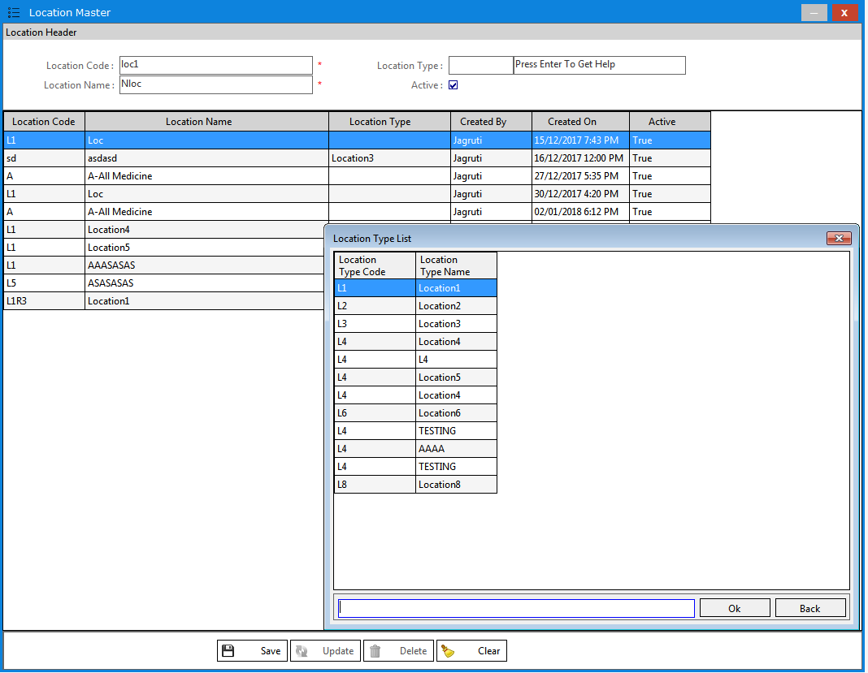

Drug Master
- _{Drug Category/Group}
Drug Category/Group contains different type of Category & Group. This Categories & Groups are system generated. User can not add/edit/delete Drug Category/Group.
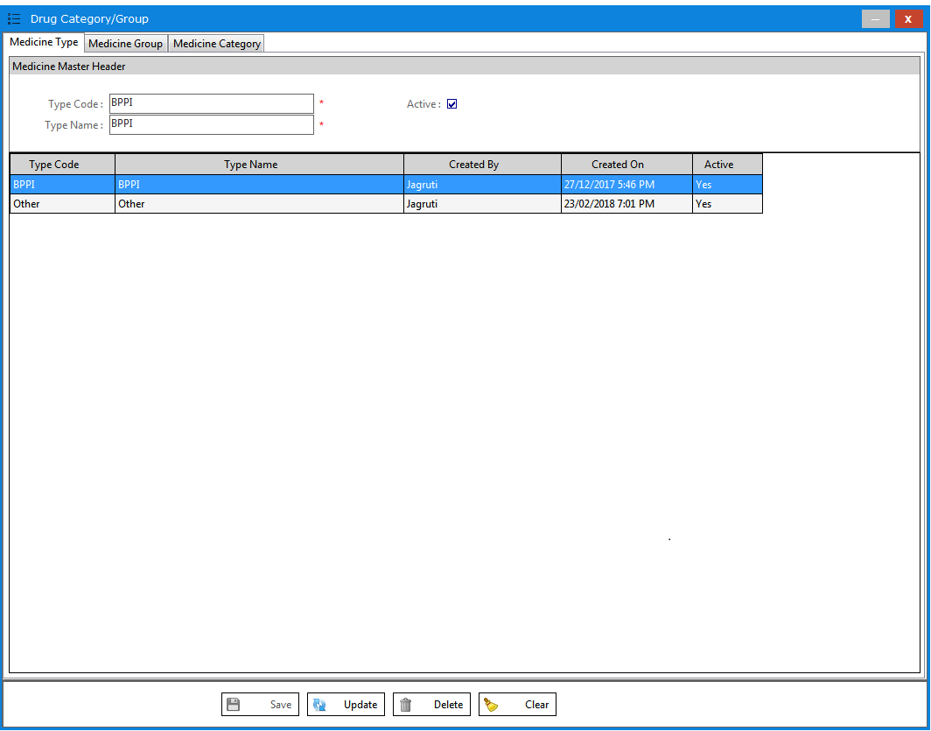

- _{Drug Master}
Drug Master contains Drugs Item. Drug Master is system generated. User can add Item Only in other Category. Drug Master Auto sync with CPOS/SAP.

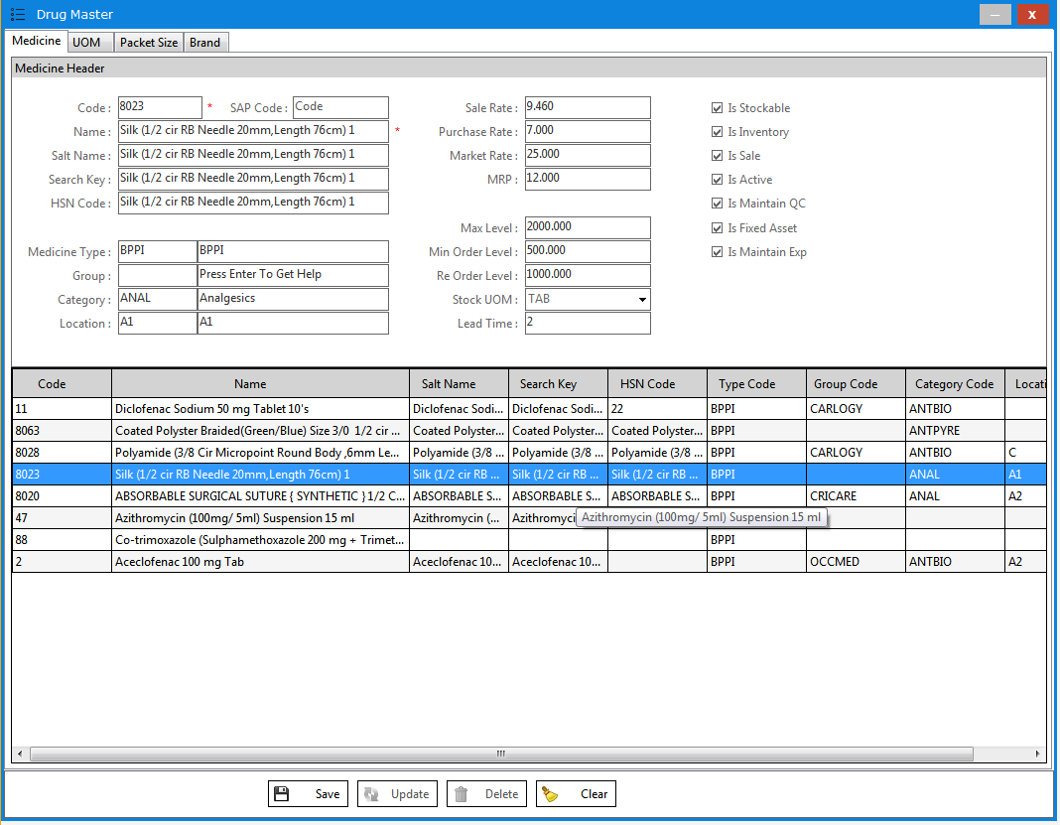

- _{Unit Master}
Unit Master contains different Unit of Drugs. Unit Master is system generated. User can not add/edit/delete Drug Category/Group.

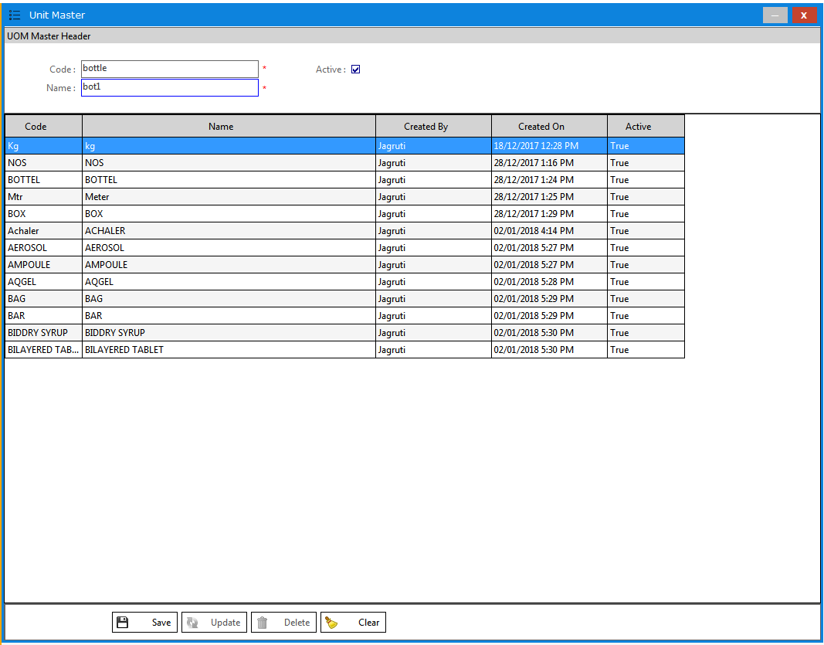

Patient Master
- _{Patient master}
Patient Master contains Patient’s Details. User can add/edit/delete Patient’s details from Patient Master.

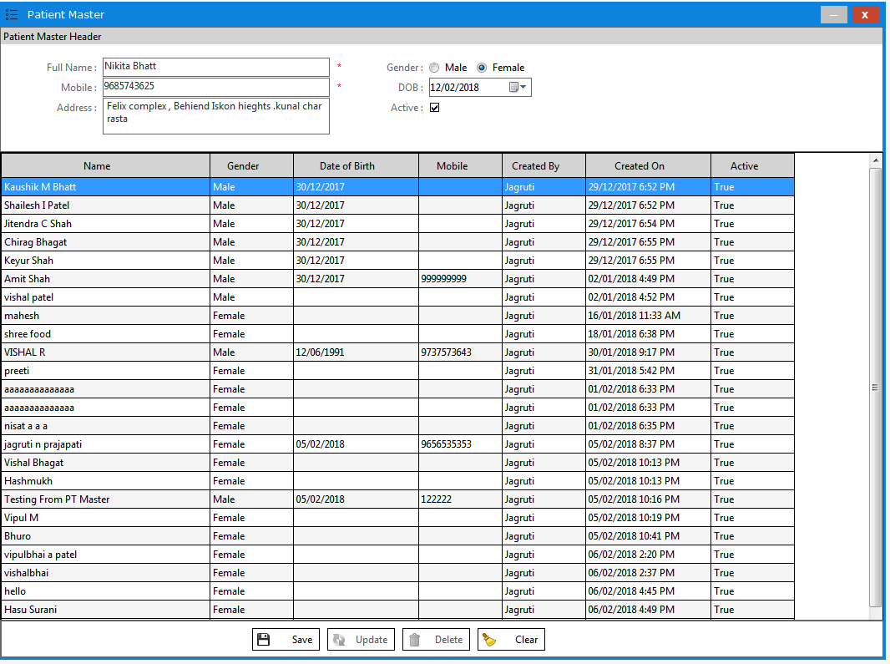

Doctor Master
- _{Doctor Master}
Doctor Master contains Doctors Details. User can add/edit/delete Doctor’s details from Doctor Master.

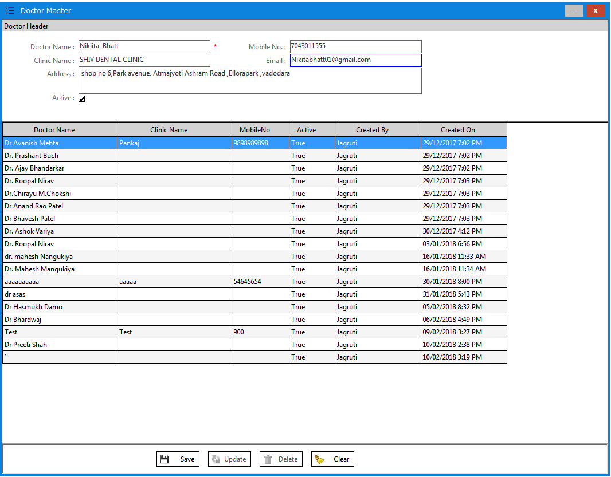

Configuration
- _{User Master}
User Master contains types of user (admin/user). Admin user can create/edit/delete User, other Users can not create/edit/delete User. Only admin user has permission.

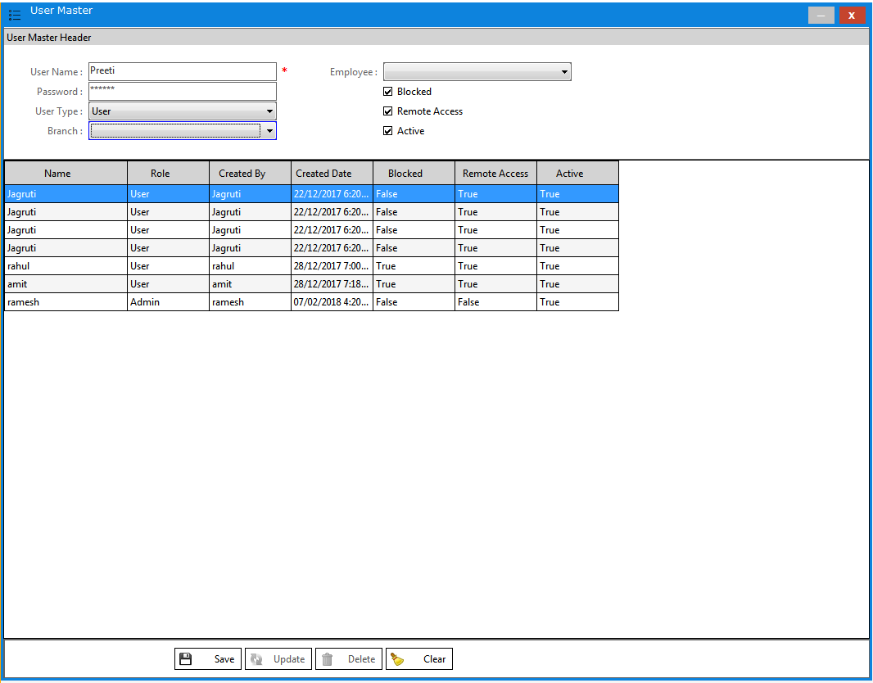

- _{User Rights}
User Rights contains types of user rights. Admin user can assign/edit/delete user’s rights, other Users can not assign/edit/delete user’s rights. Only admin user can assign rights.

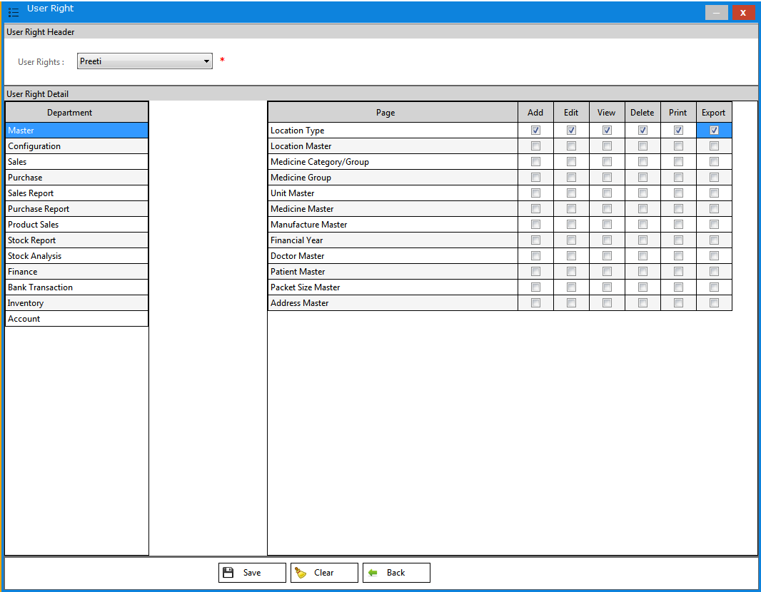
Sales
- _{Add Sale Invoice}
User can add/edit/delete sales invoice. User can take print invoice also from here. User can sale only those medicine which are provide from CPOS/SAP.

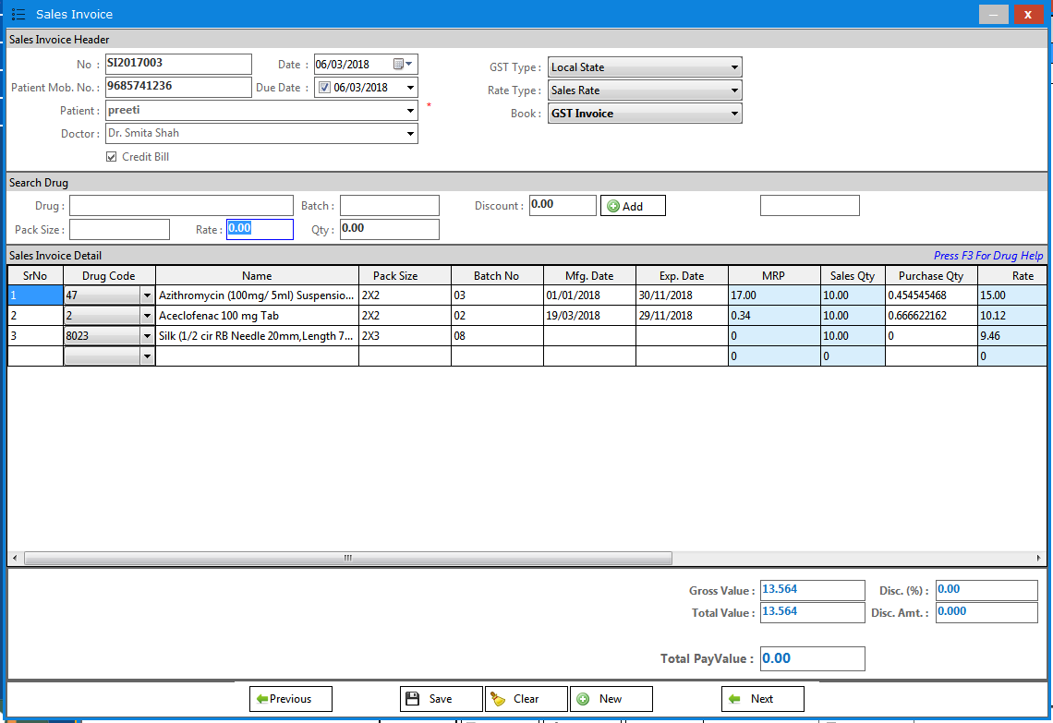

- _{Sale Return}
Sales return contains returning of sales invoice. User can return drug from Sales Return.

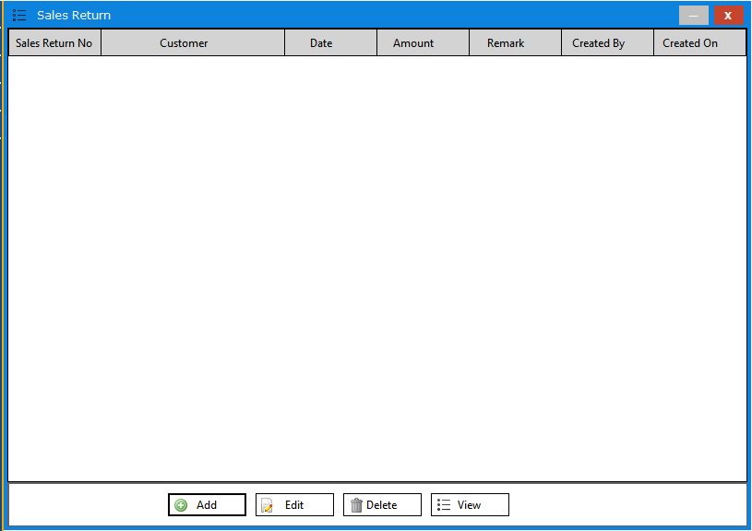

Purchase
- _{Vendor Master}
Vendor Master contains Supplier List. User can add/edit/delete only other vendor than BPPI.

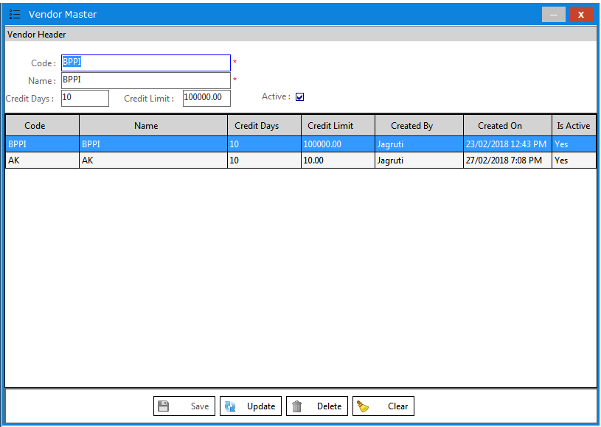

- _{Vendor Address}
Vendor Address contains Supplier List. User can add/edit/delete only other vendor address details than BPPI.

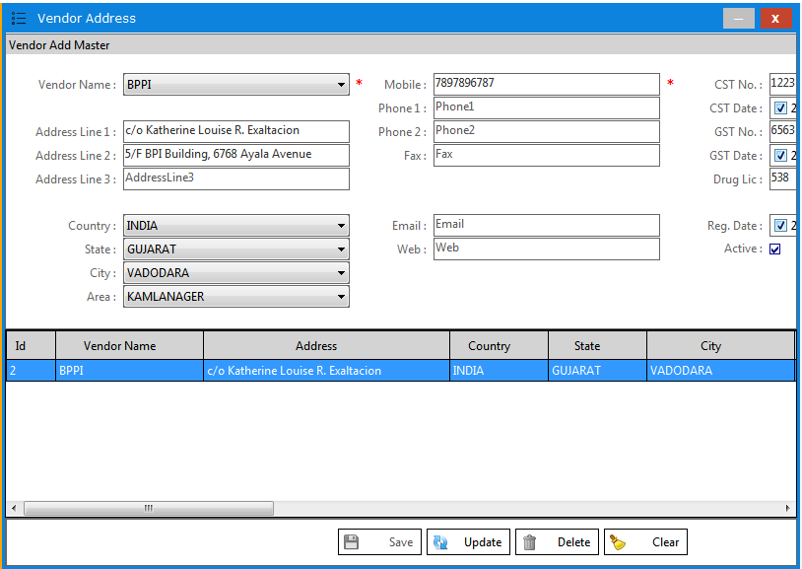

- _{Purchase Request}
Purchase request contains Purchase Indent List. User can make requirement of drug list which are out of stock or on reorder level.

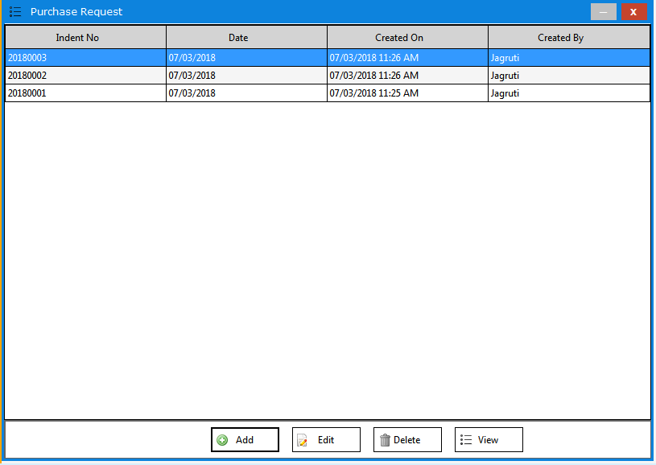

- _{Purchase Order}
Purchase order contains order of drugs. User can add/edit Purchase Order which is listed in purchase indent or other than indent drug. Purchase Order is sync with CPOS/SAP. Once order is generate User cannot edit/delete PO. User can add/edit/delete other vendor PO.

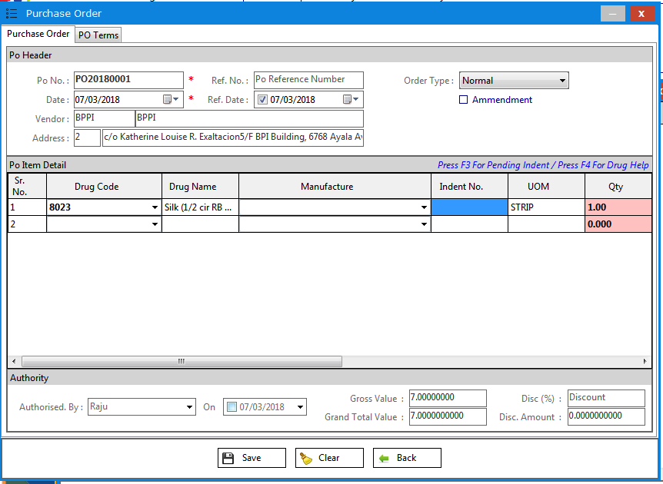

- _{Purchase Invoice}
Purchase Invoice contains purchase invoices which are derived from purchase orders. User can add/edit purchase invoice. Purchase invoice is sync with CPOS/SAP. User can also add/edit/delete other vendor invoices.

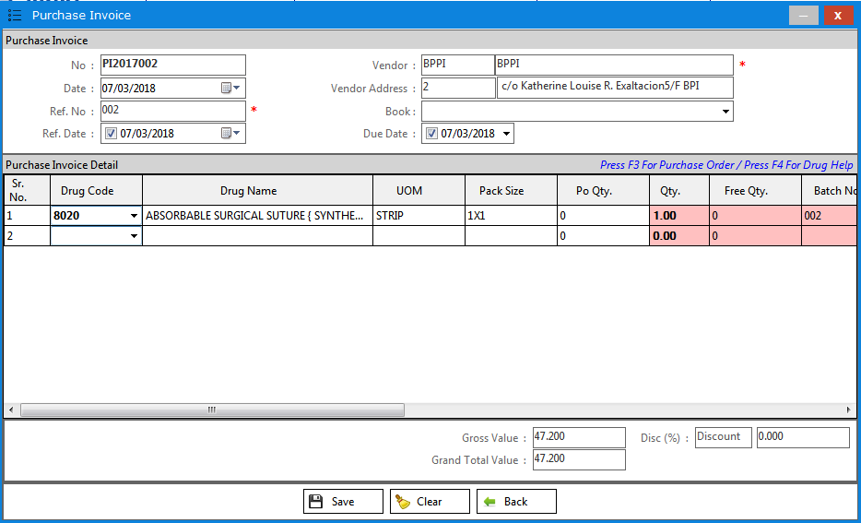
- _{Purchase Return List}
Purchase Return List contains retuning of Purchase Invoice List. User can see purchase return list which returning by User.

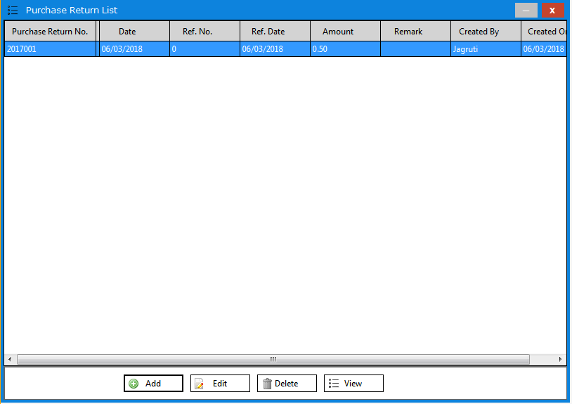

- _{Purchase Return}
Purchase return contains returning of purchase invoice. User can return drug from Purchase Returns.

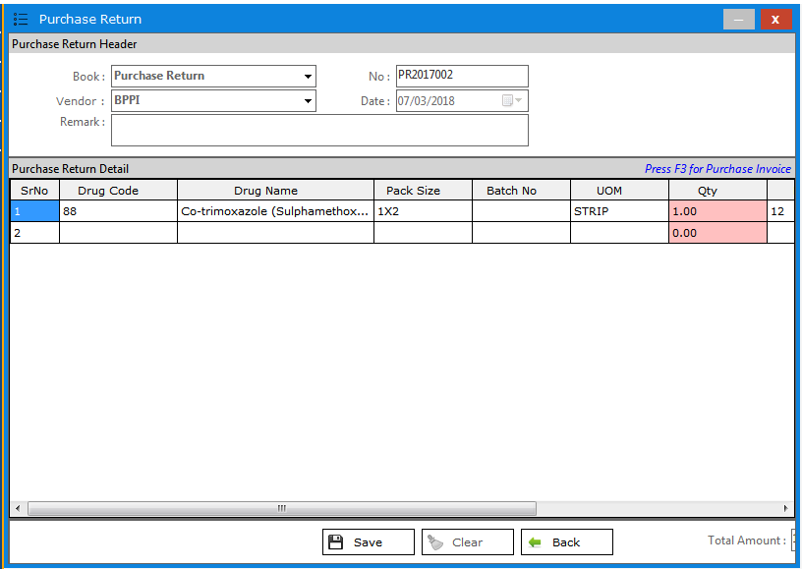

Inventory
- _{Opening Stock}
Opening stock register contains opening of drugs. User can add/edit/delete opening stock of drugs from opening stock register.

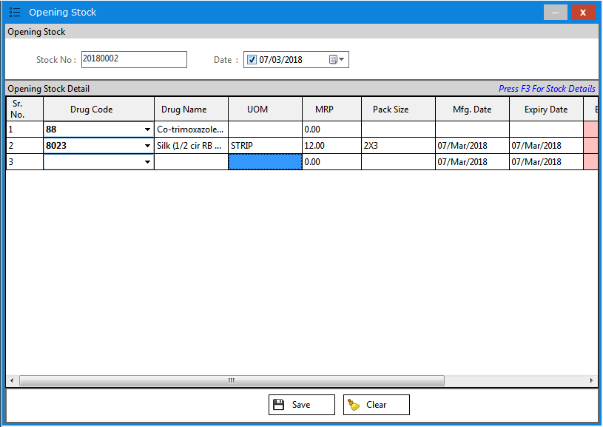

- _{Batch wise Stock Register}
Batch wise stock register contains stock of drugs which having multiple batch. User can see batch wise stock of drugs from batch wise stock register.

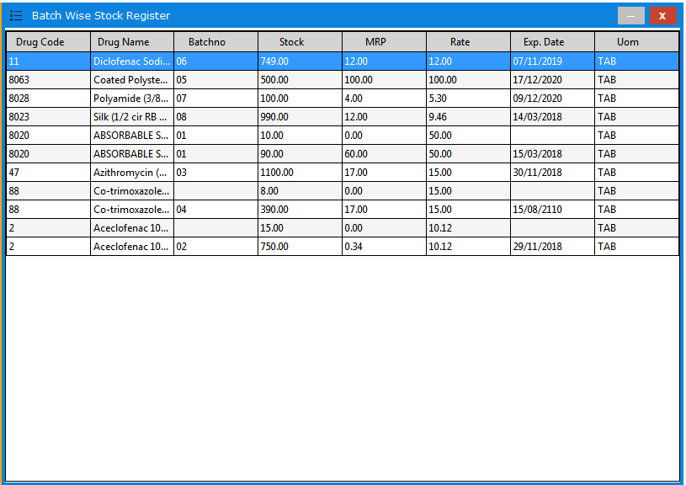

- _{Expired Stock Register}
Expired stock register contains stock of drugs which are expired. User can see expired stock of drugs from expired stock register.

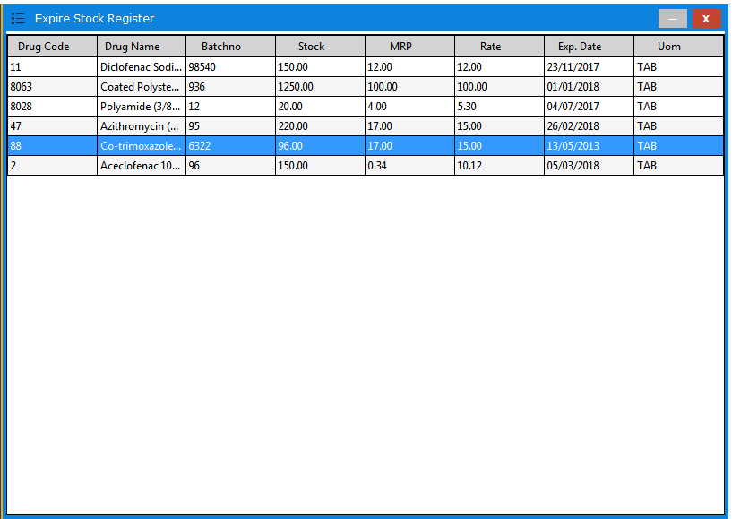

Account
- _{Account Master}
Account Master contains various account entries. User can create/edit/delete clients & bank accounts.

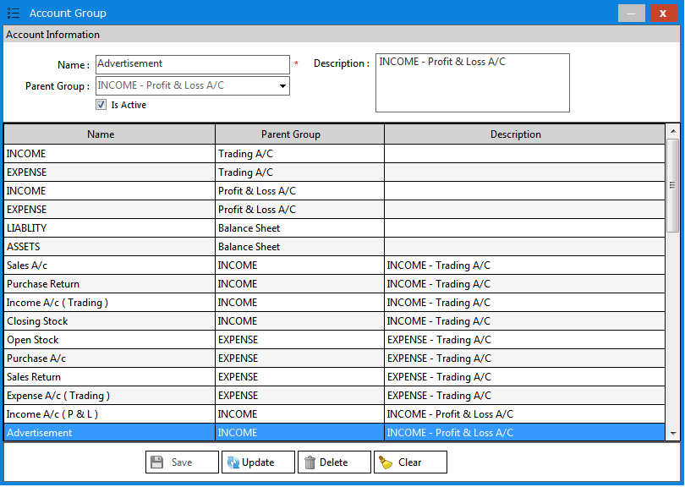

- _{Bank List}
Bank List contains Bank Receipt/Payment entries. User can see bank receipts which received from client & bank payments which paid to vendor.

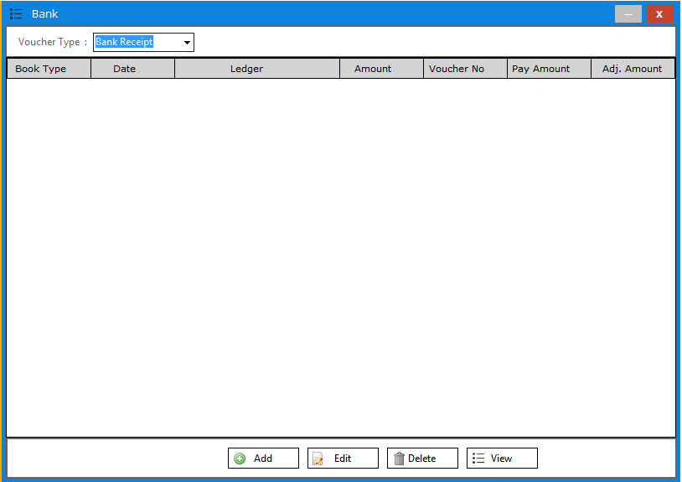

- _{Bank Add}
Bank Add contains Add Bank Receipt/Payment entry. User can add/edit/delete bank receipt against sales invoices & bank payment against purchase invoices. User can also add/edit/delete expenses & other bank entries.

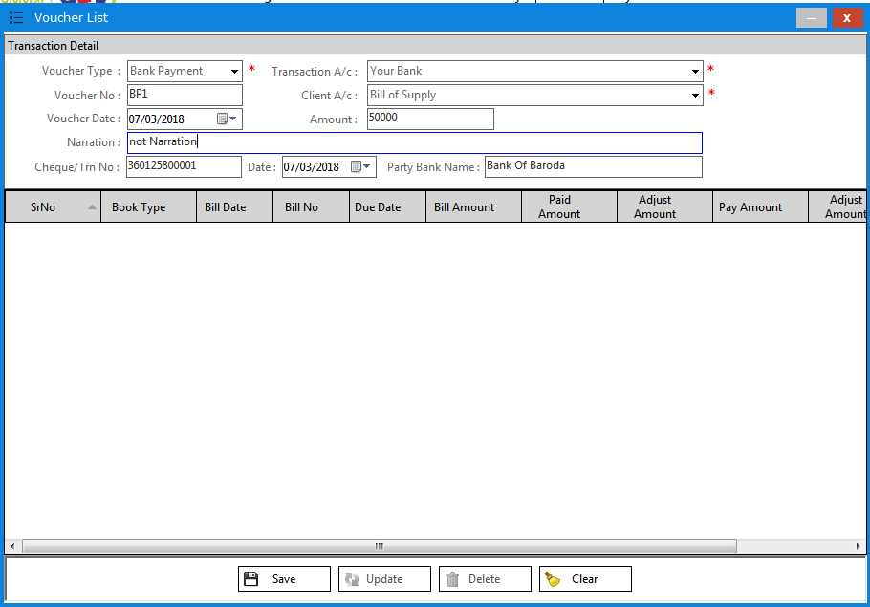

- _{Cash List}
Cash List contains Cash Receipt/Payment entries. User can see cash receipts which received from client.

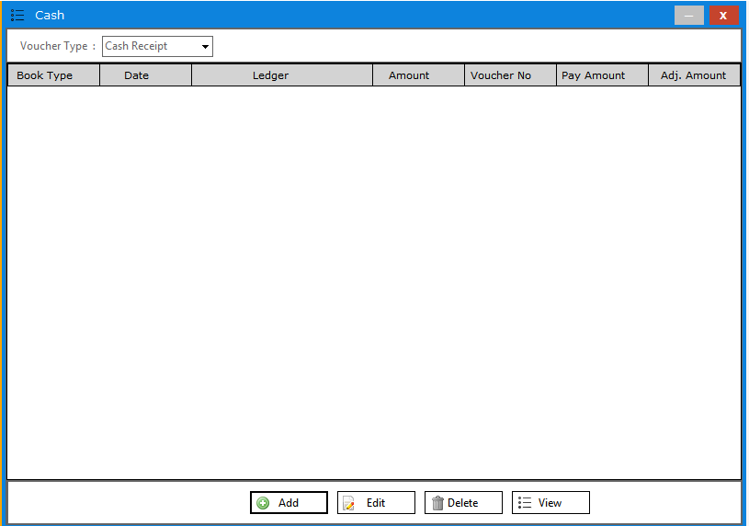

- _{Cash Add}
Cash Add contains Add Cash Receipt/Payment entries. User can add/edit/delete cash receipt against sales invoices. User can also add/edit/delete expenses & other cash entries.

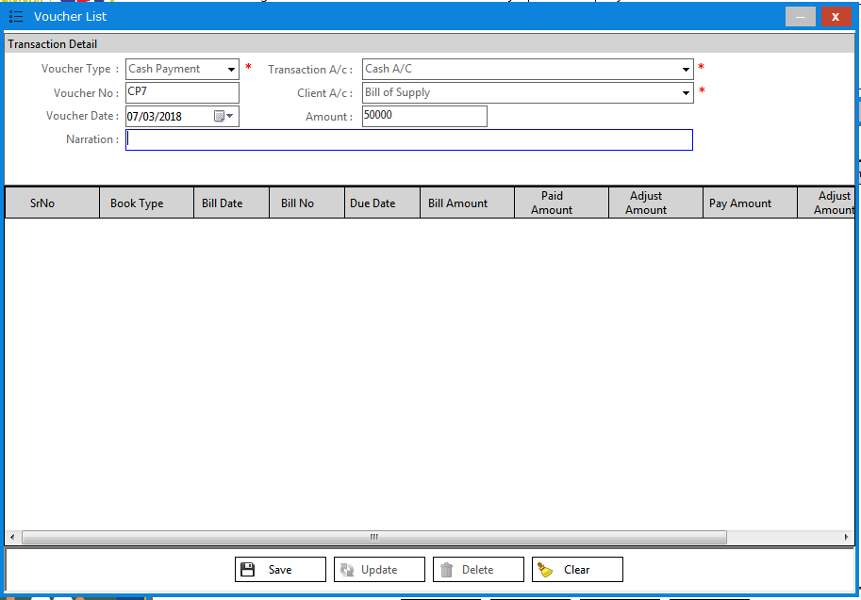

- _{Ledger Report}
Ledger Reports contains financial reports of clients & vendor. User can see financial ledger of clients, vendor, expenses & other misc. ledger.

s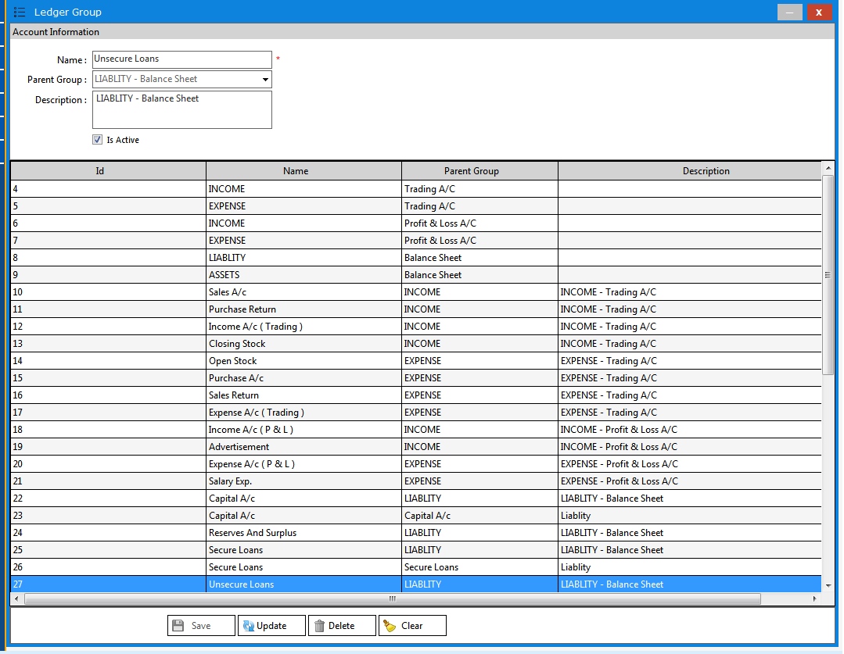

Reports
- _{Sales Report}
Sales Reports contains Sales & Sales with product details reports. User can see sales report date wise, detail wise and summary wise.
- _{Purchase Report}
Purchase Reports contains Purchase & Purchase with product details reports. User can see purchase report date wise, detail wise and summary wise.
- _{Stock Reports}
Stock Reports contains stock register, batch wise stock reports, expiry stock reports, nearby expiry reports, non-moving stock reports, rack wise stock, out of stock reports.
- _{Account Reports}
Account Reports contains Cash Reports, Bank Reports, Account/Party Ledgers, Opening Balance, and Credit/Debit Note Reports.
- _{GST Reports}
GST Reports contains GSTR-1, Purchase/Sale HSN Code Summary wise.

